# ADSORPTION, ELASTIC CHARACTERISTICS OF POROUS POLYSTYRENE, RADIATION CROSSLINKED HYDROGELS AND AUTOMATED SYSTEM

**L. O. Burlachenko, Y. A. Onanko, D. V. Charny, A. P. Onanko, M. P. Kulish, O. P. Dmitrenko, S. A. Vyzhva**

*Taras Shevchenko Kyiv national university, Volodymyrs’ka str., 64, Kyiv 01601, Ukraine, e-mail: onanko@univ.kiev.ua*

*Bandages from the radiation cross-linked hydrogels show by itself elastic films with thickness h = 2÷4 . 10-3 m – transparent jelly sterile material, that with C = 85÷90% consists of distillate water. Such bandages for wounds for the grant of the urgent help at bleeding, burns must be biologically compatible and not stick to the wounds. They can contain antiseptic, anaesthetic, haemostatic. The software is developed for the automated system of anisotropy parameters analysis.*

## Description of approach and techniques

The measuring error of the elastic module relative changing was ≈ 0,1%, the measured velocity error is equal  = 0,5÷1,5% [1]. Modernizing device USMV-KSU measuring by the echo-impulse method on frequency f1 ≈ 1,67 MGz and f2 ≈ 5 MGz is represented on fig. 1.

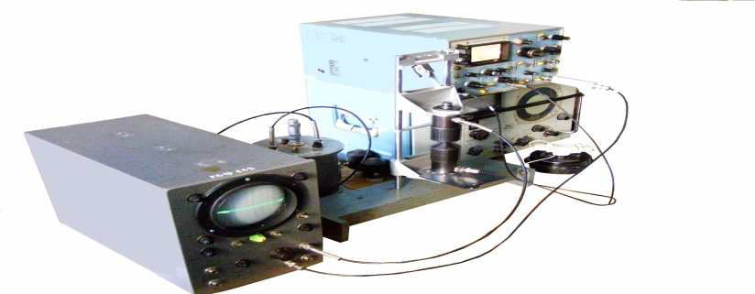

*Fig. 1. Modernizing device USMV-KSU measuring by the echo-impulse method on frequency f1 ≈ 1,67 MGz and f2 ≈ 5 MGz*

The ultrasound (US) device KERN-SG, computer device KERN-4 measuring of velocities is consist in measuring block and computer with operation system “Windows XP” are represented on fig. 2, fig. 3. The program КЕRN-4 ensures the management of measured block basic subsystems, the reflection of receiving signal in digital oscilloscope regime, which remember, and the calculation of ultrasound velocity and indication of its size on indicators. The measuring block is consist of generator, force magnifier, management-1 module, management-2 module, receiver, power module. The management block is consist of the generator created pair impulses selection scheme, which follow with clock rate, the standard and measuring impulses forming scheme and synchronization scheme of deflection. The frequency range f = 0,3÷2 MGz [1].

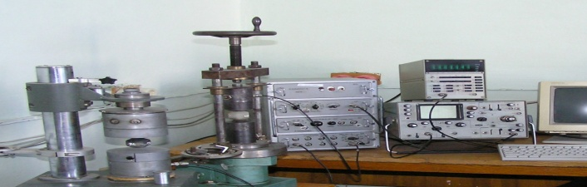

*Fig. 2. The ultrasound device KERN-SG of elastic waves velocities measuring*

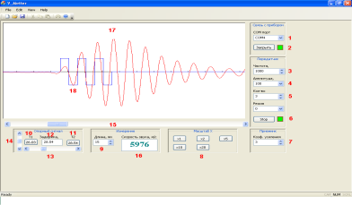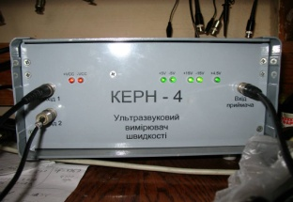

*Fig. 3. The window illustration of data treatment of elastic waves velocities measuring by the echo-impulse method on frequency f║ ≈ 1,11 MGz, f┴ ≈ 0,43 MGz and appearance of computer device KERN-4.*

The ionization of hydrogels with thickness layers h = 2÷4 . 10-3 m was carried out by the relativistic electrons irradiation with energy of W ≈ 1 MeV or W ≈ 4 MeV. The dependences of efficiency of the radiation cross-linked were investigated after mechanical characteristics from the fluence F, radiation dose D. The radiation cross-linked hydrogels (CLHG) hydrophilicity and gas-penetrability were investigated as the function of them chemical composition and terms of electrons irradiation.

It is 3D polymeric net of porous polystyrene + amorphous colloid Fe(OH)3 - is the sponge with the pores size d ≤ 103 nm, due to it contains distillate water, assumes the diffusion of solutions, but does not skip the bacteriums on fig. 4.

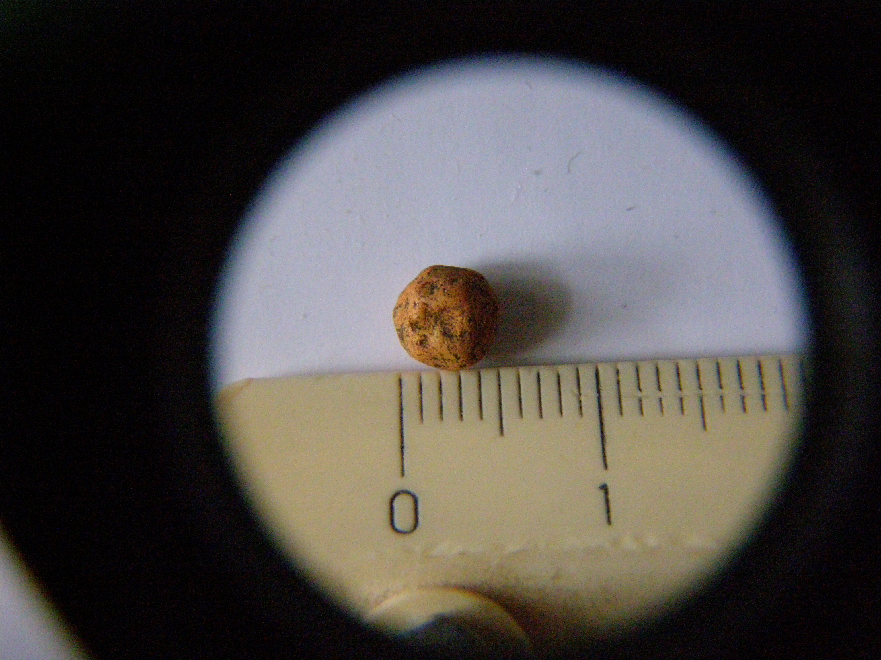

**1000 nm**

*Fig. 4. Microstructure of porous polystyrene + amorphous colloid Fe(OH)3, az adsorption centres of over the norm concentration Mn2+ after oxidation of microorganisms Fe2+ → Fe3+ after 10 functioning years*

## Results and discussion

The Puasson coefficient μ is equal toratio of relative transversal compression to relative longitudinal lengthening and equal:

. (1)

The quasilongitudinal ultrasonic (US) velocity  = 504 m/sec, dynamical elastic module  = 15,24 МPa, “fast” quasitransversal US velocity  = 280 m/sec, shear module  = 4,704 MPa, Puasson coefficient μ = 0,3532, specificdensity ρ = 60 kg/m3 of porous polystyrene are determined from the oscilloscopegramma on fig. 5.

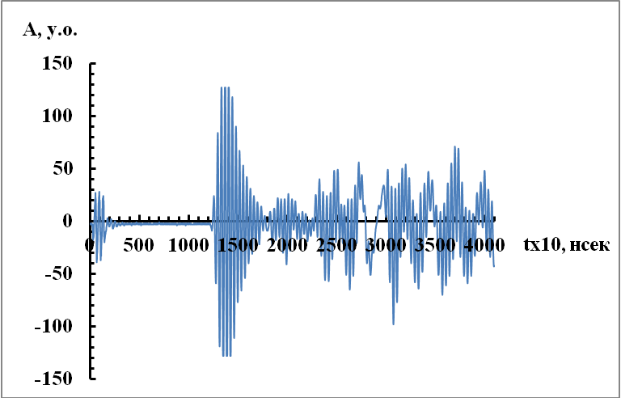

*Fig. 5. Oscilloscopegramma of impulses with quasilongitudinal polarization  in porous polystyrene*

The static elastic module Е ≈ 147,3 КPа at compression, Е ≈ 105,3 КPа at extension; elastic limit σЕ ≈ 38 KPa, effective fluidity limit σfl ≈ 82 КPа; strength limit at compression σst ≈ 145 КPа for the radiation cross-linked hydrogel + 10% polyvinyl alcohol (C2H4O)n were measured.

## Conclusions

1. The decreasing of static elastic module E at elastic module at compression, at extension; elastic limit σЕ; effective fluidity limit σfl; strength limit at compression σst of porous polystyrene, radiation sutured hydragel with increasing concentration polyvinyl spirit are discovered.

2. The optimum concentration С = 5% of polyvinyl alcohol (C2H4O)n radiation cross-linked hydrogel with the maximal absolute values of the elastic limit σЕ; static module E at compression, at extension; strength limit at compression σst in consequence of the formation of the polyvinyl alcohol molecules nanoclusters.

ис.1 к статье О.В.Ляшенко, А.П.Онанко ″Влияние электрического тока на упругие и неупругие характеристики **Ge0.963Si0.037**″.

à

ис.1 к статье О.В.Ляшенко, А.П.Онанко ″Влияние электрического тока на упругие и неупругие характеристики **Ge0.963Si0.037**″.

à

## References

1. Y. A. Onanko, G. T. Prodayvoda, S. A. Vyzhva, A. P. Onanko, N. P. Kulish, “Automated system of treatment of ultrasound longitudinal and transversal velocities measuring”, Metalphysics and new technology, vol. 33(13), pp. 529-533, 2011.